Infosys Springboard Virtual Internship 6.0 Completion Report

Team Details: Team A

Batch Number: 13 “Receipt and Invoice Digitizer”
Start date : 02-02-2026
Names:
Ankit Sharma
Hemanjali Kodali
Rethika S
nirupama pardhu nakketla
Sandana Aini
Internship Duration: 8 Weeks

1. Project Title
Receipt and Invoice Digitizer

2. Project Objective

Receipt and Invoice Digitizer is an AI-assisted document processing system designed to automate the extraction, organization, and analysis of financial documents such as receipts and invoices. The objective of the project is to eliminate manual data entry by allowing users to upload invoice images and automatically convert them into structured digital records. Using OCR-based text extraction and intelligent data parsing, the system identifies key details including vendor name, invoice number, total amount, and date, and stores them in a centralized database.

The platform provides an interactive dashboard where users and administrators can view, search, and analyze invoice data through visual charts, tables, and analytics tools. By transforming unstructured invoice images into organized data, the system improves accuracy, reduces processing time, and simplifies financial record management. Additionally, the application supports multiple user roles, enabling both individual users and administrators to efficiently manage invoices and gain insights into spending patterns. Ultimately, the project aims to build a scalable and user-friendly platform that streamlines invoice digitization, enhances financial transparency, and supports smarter data-driven decision making.

3. Project description in detail

Receipt and Invoice Digitizer is an AI-assisted web application developed to simplify and automate the process of managing receipts and invoices in digital form. The project addresses a common challenge faced by individuals and organizations: handling large numbers of financial documents manually. Traditional invoice processing often involves reading paper receipts, manually entering data into spreadsheets or accounting systems, and storing documents for future reference. This process is slow, error-prone, and inefficient. The Receipt and Invoice Digitizer solves this problem by automatically extracting key information from uploaded invoice images and converting it into structured, searchable data.
The system allows users to upload receipts or invoices in image format through a web-based interface. Once the document is uploaded, the backend processes the image using Optical Character Recognition (OCR) technology to extract textual information from the invoice. The extracted raw text is then analyzed and converted into structured fields such as vendor name, invoice number, total amount, and invoice date. This structured data is stored in a database and linked with the original uploaded file, enabling users to easily retrieve, review, and manage their financial records in a centralized platform.
The application is built using a modern full-stack architecture that combines a Python-based FastAPI backend with a React-based frontend dashboard. The backend handles user authentication, file uploads, OCR processing, and API communication, while the frontend provides an interactive interface for viewing, searching, and analyzing invoice data. The user interface is developed using React, Vite, Tailwind CSS, and shadcn UI components, ensuring a responsive and visually clean design. Additional libraries such as Axios enable communication between the frontend and backend APIs, while Framer Motion enhances the user experience through smooth animations and transitions.
One of the central components of the system is the admin dashboard, which provides a comprehensive overview of invoice-related data. The dashboard displays useful analytics such as the total number of invoices processed, revenue summaries, monthly revenue trends, and vendor distribution statistics. These insights are presented using charts, tables, and visual summaries that help users quickly understand their financial activity. The invoices management page further allows users to search invoices by vendor name or invoice number, filter invoices using dropdown menus, and inspect detailed invoice information in a split-screen interface. Users can also view the original uploaded invoice image alongside the extracted data for verification.
The system also incorporates frontend data processing utilities that normalize invoice data and generate analytics used in the dashboard. These utilities compute insights such as revenue by month, top vendors, and currency-based revenue summaries. This data transformation ensures that the dashboard components receive consistent and well-structured information for visualization.
The platform supports multiple user roles, including regular users and administrators. Standard users can upload invoices and access their stored records, while administrators have access to advanced analytics and system-wide invoice management tools. This role-based functionality allows the platform to be used effectively by individuals managing personal receipts as well as organizations processing large volumes of financial documents.
Overall, the Receipt and Invoice Digitizer project aims to demonstrate how artificial intelligence and modern web technologies can be combined to automate document processing and financial record management. By transforming unstructured invoice images into organized digital data and presenting it through an intuitive analytics dashboard, the system improves efficiency, reduces manual effort, and enables users to gain meaningful insights from their financial documents.

4. Timeline Overview
Week | Activities Planned | Activities Completed
Week 1 | Requirement gathering, project scope definition, and resource allocation | Requirements finalized, project scope documented, team roles assigned
Week 2 | Research on AI/ML models for expense forecasting and selection of development tools/tech stack | Explored OCR tools (Tesseract), selected FastAPI for backend and React for frontend
Week 3 | Database design and setup for income/expense data | Backend project initialized, database schema created for invoice records
Week 4 | Data collection, preprocessing, and integration with dummy financial data | Developed file upload API and integrated OCR for extracting text from invoice images
Week 5 | Model development: Training AI/ML algorithms on expense forecasting | Implemented text cleaning, validation rules, and structured fields (vendor, date, amount)
Week 6 | Development of user interface (dashboard, charts, visualization) | Built dashboard with tables and charts for viewing uploaded invoices
Week 7 | System integration: Linking AI model, database, and UI | Integrated APIs with UI, enabled invoice viewing, filtering, and data visualization
Week 8 | Testing, debugging, documentation, and final project deployment | System tested with sample invoices, bugs fixed, project documented and deployed

5a. Key Milestones
Milestone | Description | Date Achieved
Project Kickoff | Project kickoff defined objectives, scope, and roles. | 10 –Feb- 2026
Prototype/First Draft | Developed the prototype for resume matching and skill recommendation. | 17 -Feb – 2026
Mid-Term Review | Completed mid-term review to assess progress and refine project approach. | 24 -Feb – 2026
Final Submission | Submitted the completed Budgetwise project with full functionality and documentation. | 14 -March – 2026
Presentation | Prepared and delivered the project presentation showcasing features and outcomes. | -March - 2026

5b. Project execution details

• Requirement Analysis – Gathered user needs, defined project scope, and finalized objectives.
• Technology Selection – Selected Tesseract OCR for text extraction, FastAPI (Python) for backend services, React for frontend dashboard, and LSQL for data storage.
• System Design – Designed database schema for storing invoice data and created workflow diagrams for the OCR processing and data extraction pipeline.
• Data Collection – Collected sample invoice and receipt images from various sources to test the document digitization process.
• Data Preprocessing –Implemented OCR to extract raw text from images and applied text cleaning and validation rules to structure fields such as vendor name, date, and total amount.
• Model Development – Used LLM-based parsing to convert unstructured OCR output into structured invoice data in JSON format.
• Frontend Development – Developed a dashboard interface to upload invoices, view extracted data, and analyze records through tables and charts.
• Backend Development – Built REST APIs using FastAPI for image upload, invoice processing, authentication, and data retrieval.
• Testing & Integration – Conducted unit, system, and user acceptance testing; resolved bugs.
• Deployment & Documentation – Deployed the tool on cloud, prepared user manual, and presented final demo.

6. Snapshots / Screenshots
Step 1 : Go to Github and clone the Repository in your system then open in VS Code to do the execution , here is the github repo link :
https://github.com/Ankitshrma25/Receipt_invoice_Digitilizer_team_A
Step 2 : Start the with python app.py
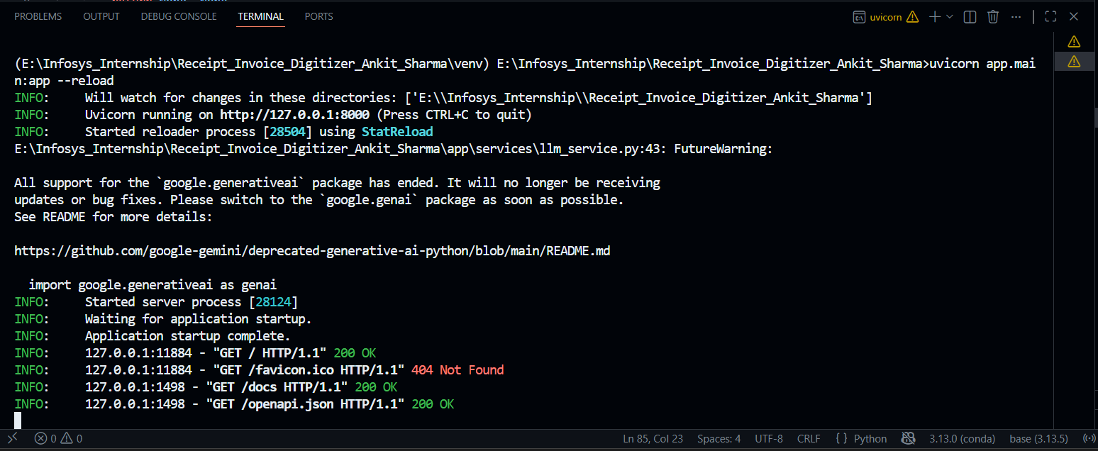

Step 3: Here is the Landing page with basic navigation and a chatbot for helping user
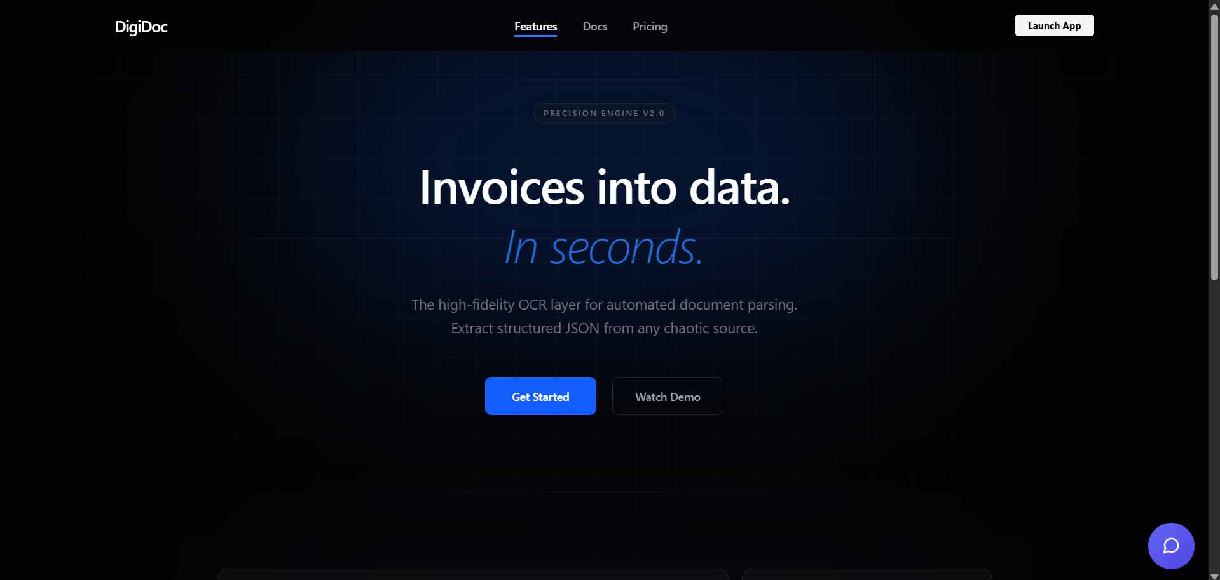

Step 4: After clicking on Login/Signup here user need to register and log in for Authentication.
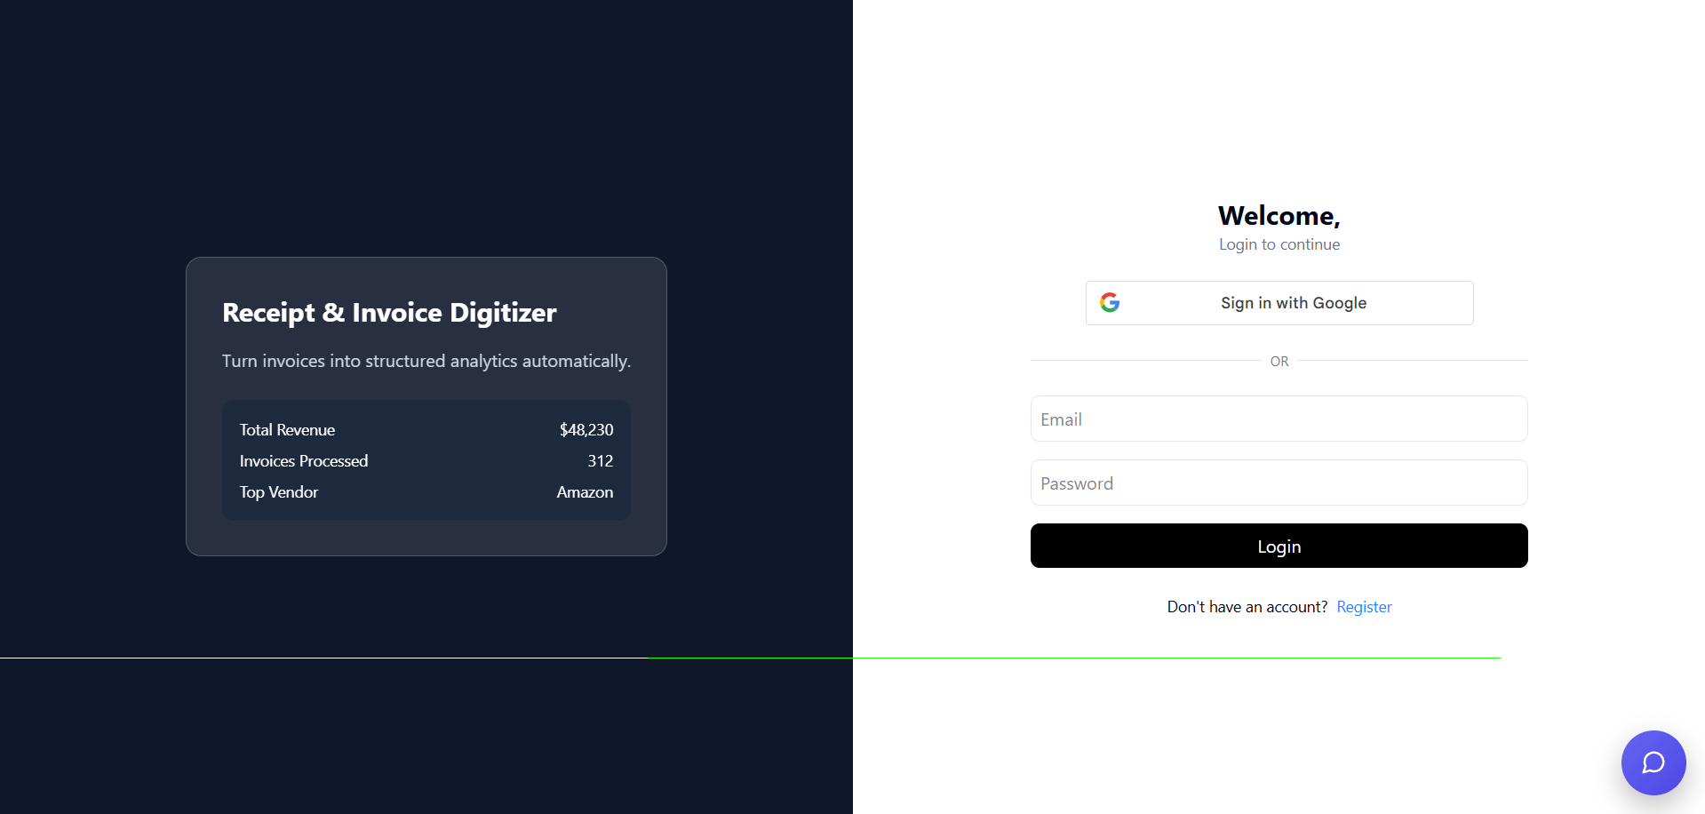
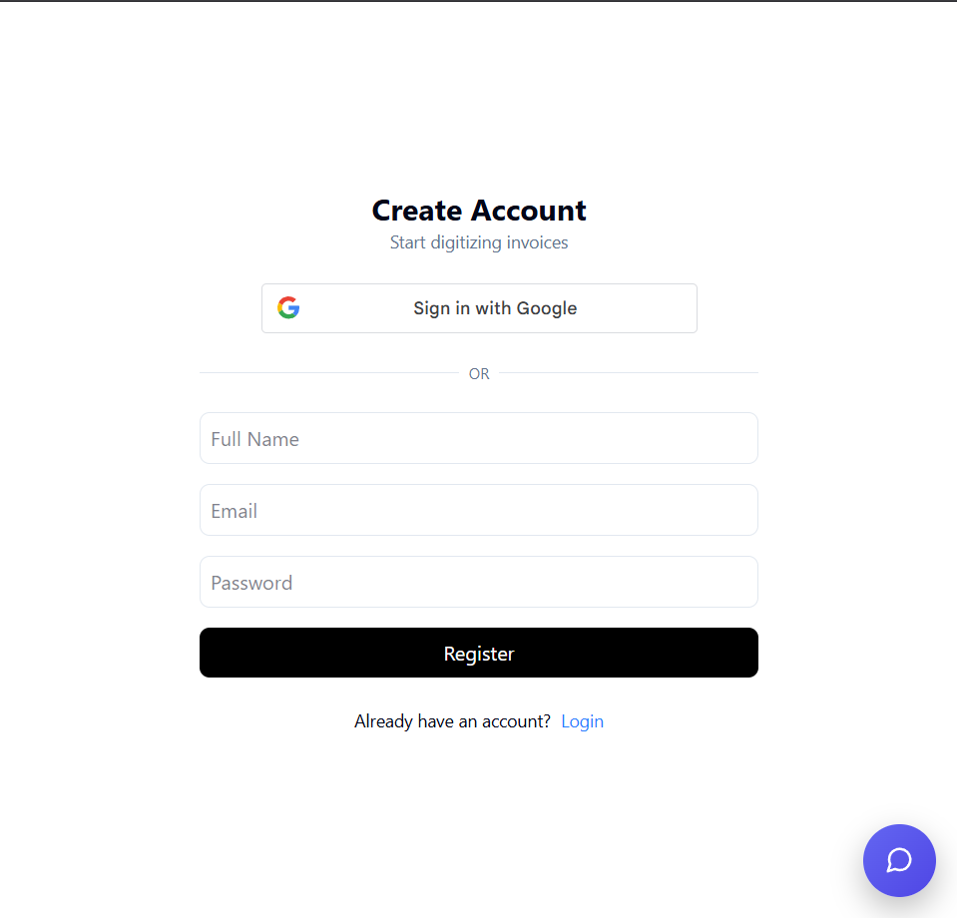

Step 5: User need to Upload the Receipt or Bill.
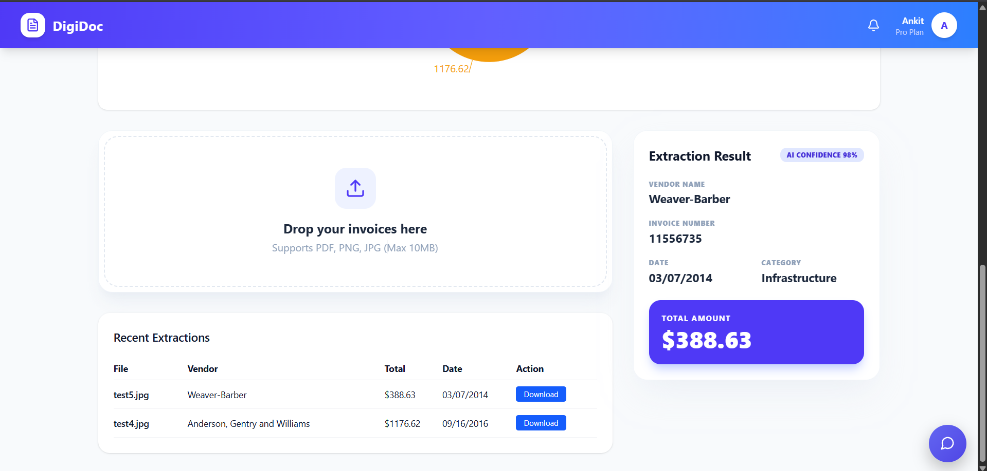

Step 6: After submitting user can see the extracted details.
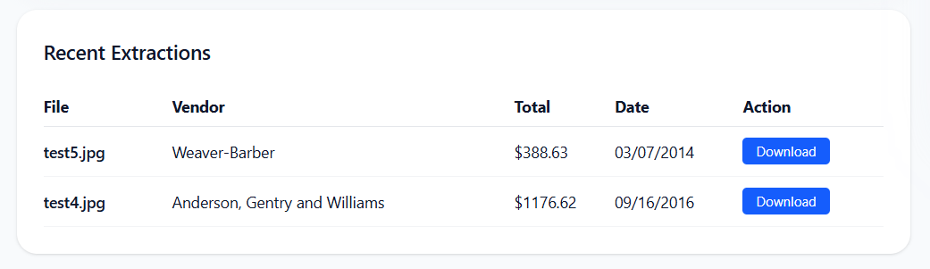

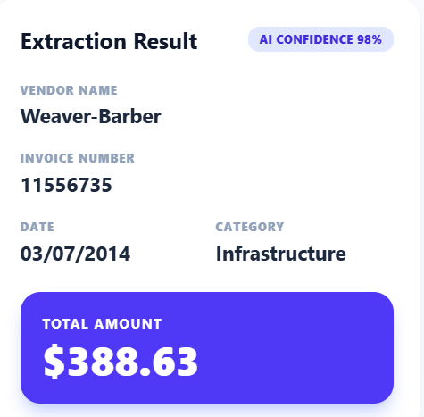

Step 7: Here is basic report also with graph and charts.
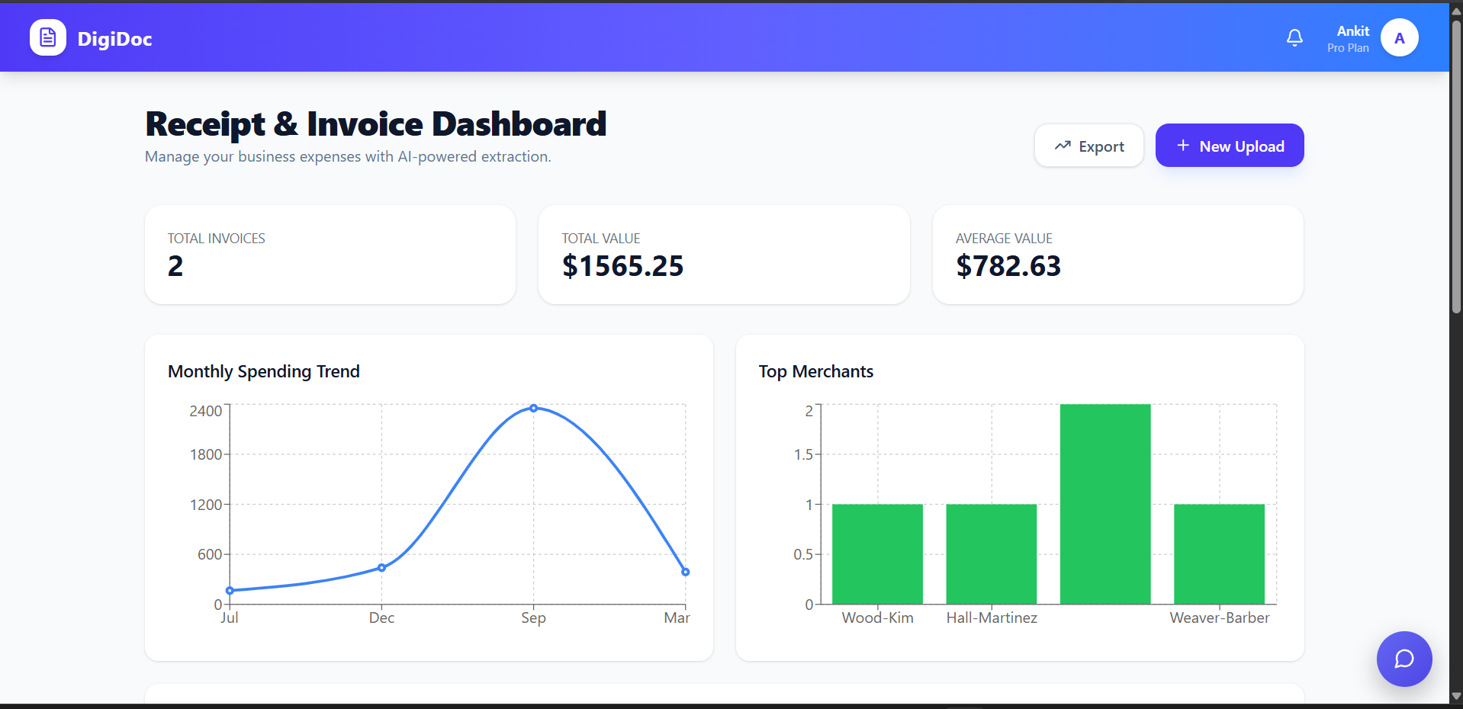



Step 8: digitized Version of the Receipted user can download.
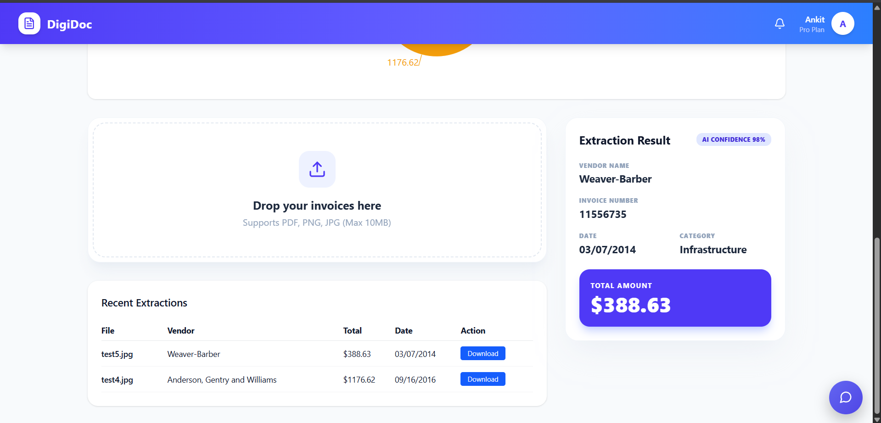

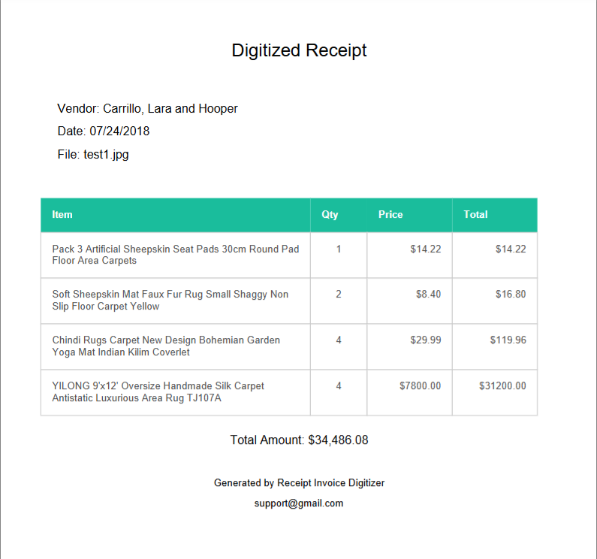
Figure shows a Digitized version of the Receipt.

Step 9: Using Chatbot user can communicate with Chatbot
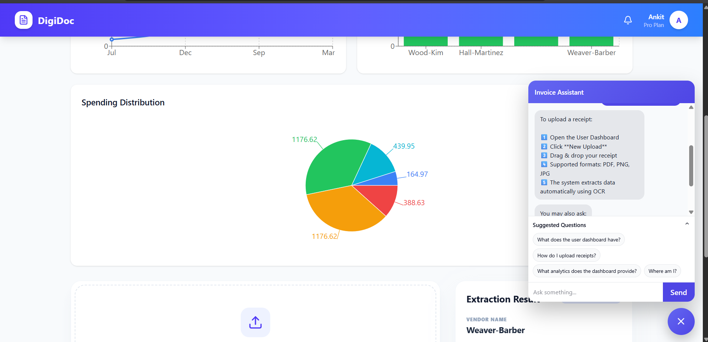
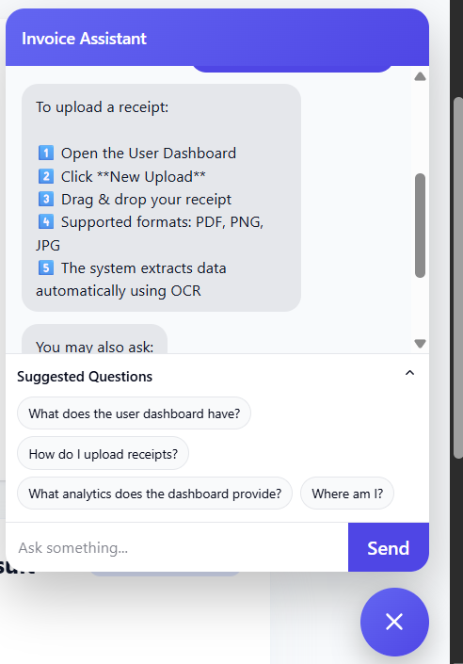

Step 10 : Admin Dashboard with full access of the App
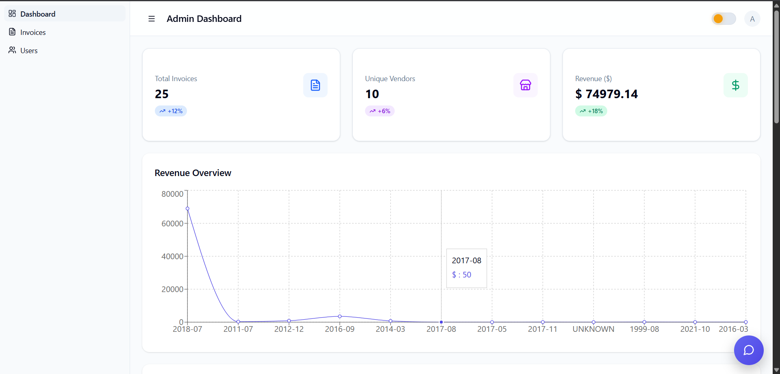

7. Challenges Faced

• OCR Accuracy Issues – Extracting text from different invoice formats was challenging due to variations in layout, fonts, and image quality.
• Unstructured Text Output – OCR results often contained noisy or incomplete text, requiring additional processing to correctly identify fields such as vendor name, date, and total amount.
• Data Standardization – Converting extracted text into structured and consistent data fields required validation rules and formatting logic.
• Handling Different Invoice Formats – Receipts and invoices from different vendors had varying structures, making it difficult to create a universal extraction pipeline.
• Backend Integration – Integrating OCR processing, LLM-based parsing, database storage, and API services required careful coordination between different components.
• API Performance – Ensuring the system could process uploaded images and return structured results quickly required optimization of the backend services.
• Frontend–Backend Communication – Connecting the dashboard with backend APIs and ensuring proper data flow during uploads and retrieval required debugging and testing.
• Error Handling – Managing incorrect OCR outputs, missing values, and invalid image uploads required implementing proper validation and error-handling mechanisms.
• Testing with Real Documents – The system needed to be tested with multiple invoice samples to ensure reliable extraction across different formats.
• Time Management – Completing backend development, OCR integration, frontend dashboard, and testing within the project timeline required careful planning and prioritization.

8. Learnings & Skills Acquired

• OCR & Document Processing – Gained practical experience in extracting text from invoice images using OCR and handling variations in layouts and formats.
• Data Processing & Validation – Learned techniques to clean, structure, and validate extracted text data to convert unstructured invoice information into usable records.
• Generative AI Integration – Applied LLM-based parsing to transform noisy OCR output into structured fields such as vendor name, date, and total amount.
• Backend Development – Strengthened backend development skills using Python and FastAPI for building APIs, handling file uploads, and processing data pipelines.
• Full-Stack Development – Improved understanding of integrating backend services with frontend dashboards for uploading and visualizing invoice data.
• Database Management – Designed database schemas and implemented storage solutions for managing structured invoice records.
• API Development & Security – Implemented REST APIs and authentication mechanisms to ensure secure access and data handling.
• System Integration – Learned how to connect multiple components such as OCR processing, LLM extraction, database storage, and UI dashboards.
• Testing & Debugging – Gained experience testing document processing pipelines and handling errors from OCR outputs and API responses.
• Project Execution Skills – Improved planning, debugging, and problem-solving abilities while managing multiple stages of development within the project timeline.

9. Testimonials from team

Team Member 1:
“This project helped me understand how OCR and AI can be used to extract structured information from documents and automate manual processes.”
Team Member 2:
“I gained hands-on experience working with backend APIs, database integration, and building dashboards to display processed invoice data.”
Team Member 3:
“The project improved my understanding of integrating AI models with web applications and handling real-world document processing challenges.”
Team Member 4:
“Working on this system strengthened my knowledge of data processing, API development, and teamwork in delivering a complete application.”

10. Conclusion

The Receipt and Invoice Digitizer project successfully developed an AI-powered system for converting invoice and receipt images into structured digital records. By combining OCR technology, backend APIs, and an interactive dashboard, the system automates the process of extracting and managing financial document data. The project enhanced technical knowledge in AI integration, backend development, and system design while delivering a practical solution that reduces manual data entry and improves document management efficiency.

11. Acknowledgements

I would like to express my sincere gratitude to Infosys Springboard for providing me the opportunity to work on the Receipt and Invoice Digitizer project and gain practical experience in AI-based document processing.
I am especially thankful to my mentor, Shakthi Gopalakrishnan, for their continuous guidance, support, and valuable insights throughout the internship. Their mentorship helped me understand the practical aspects of AI integration and backend system development.
I would also like to thank my team members for their cooperation and support during the development of this project. Their collaboration made the learning experience both productive and enjoyable.
Finally, I extend my appreciation to everyone who contributed directly or indirectly to my learning and helped me complete this project successfully.

